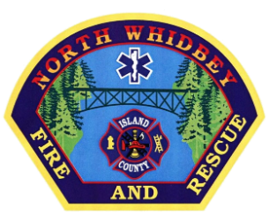
NORTH WHIDBEY FIRE AND RESCUE BOARD OF COMMISSIONERS
Administration Building, 770 NE Midway Blvd. #1 Oak Harbor, Washington
Phone: 360-675-1131 Email: Admin@nwfr.org

SPECIAL

MEETING NOTICE

A Special Meeting is scheduled for

February 24, 2019 at 1:00pm

Administrative Building
Suite 201
770 NE Midway Blvd
Oak Harbor, WA 98277

Agenda

Call to order

- Discuss Employment Agreement for New Fire Chief
- Good of the Order
- Adjourn Meeting

